1. Open the Terminal.

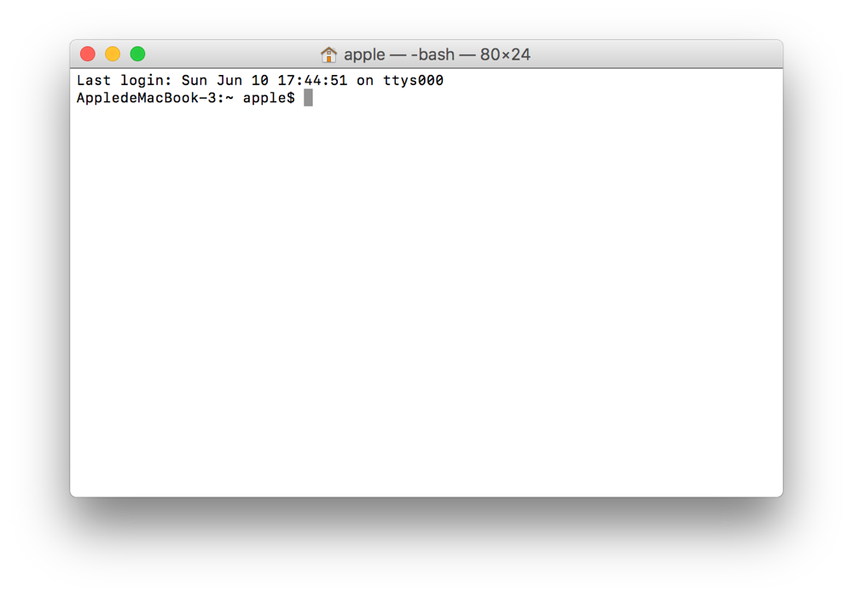

1. Input “cd desktop”, Then input“javac MathTeacher.java”and“java MathTeacher”.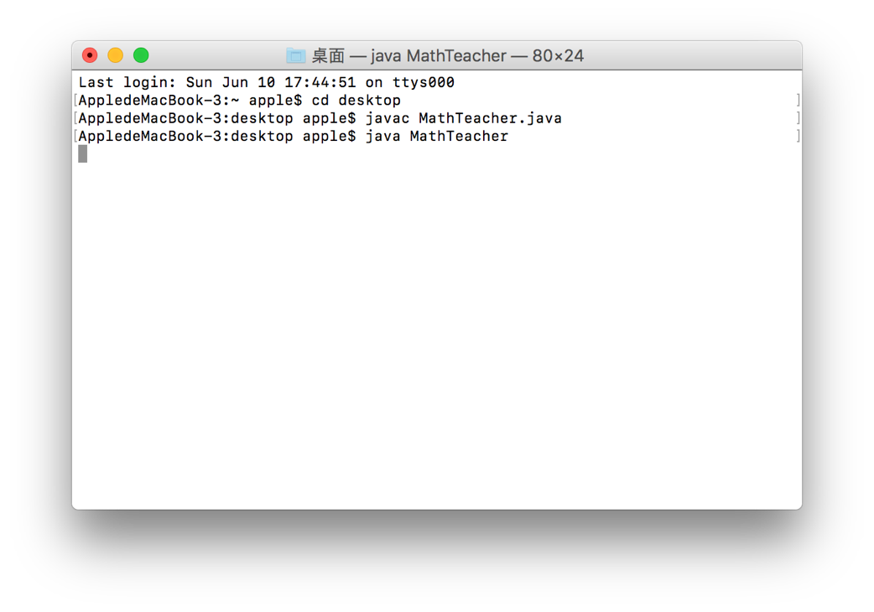
2. The GUI appears.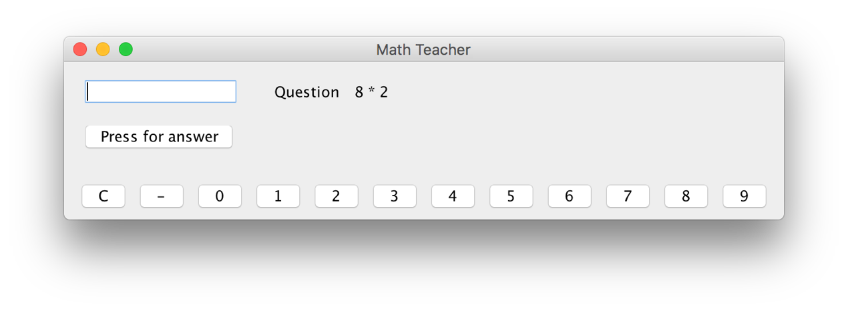
3. Read the question and input your answer. 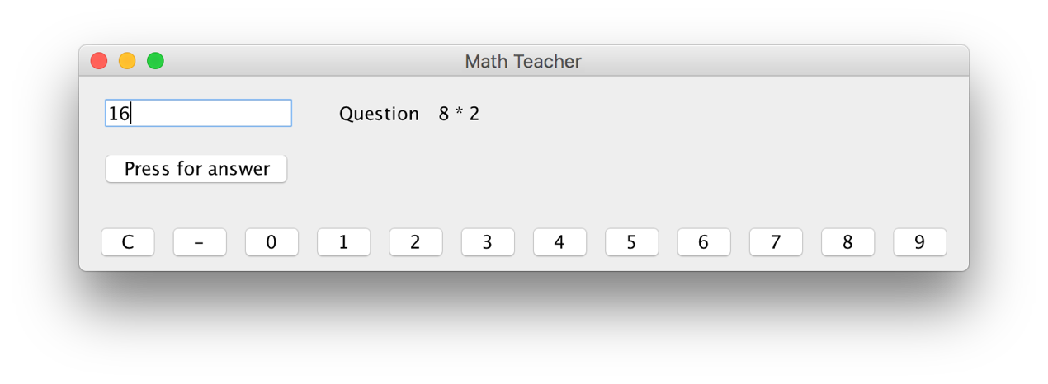
4. Press the “Press for answer” button for the judgement of your answer.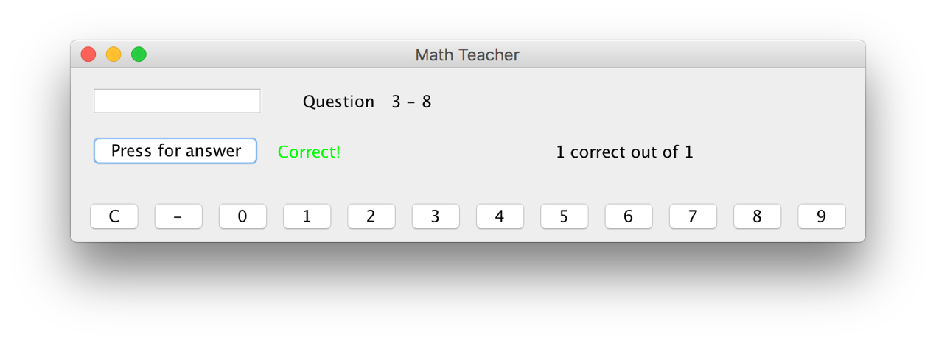
5. If you put in a wrong answer, the “Math Teacher” will tell you the correct answer.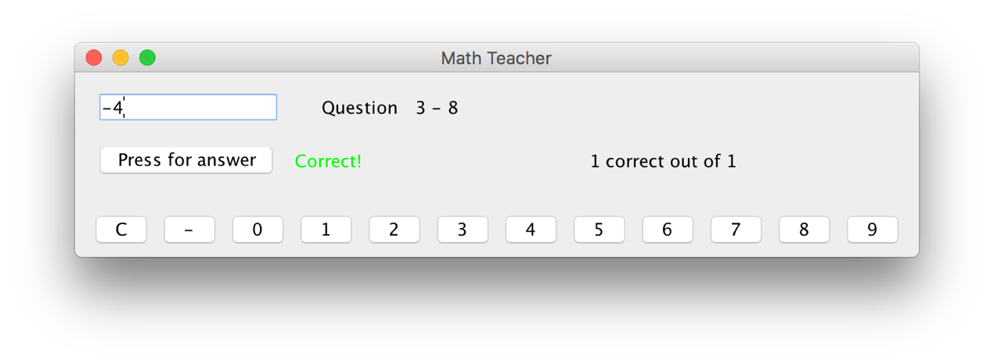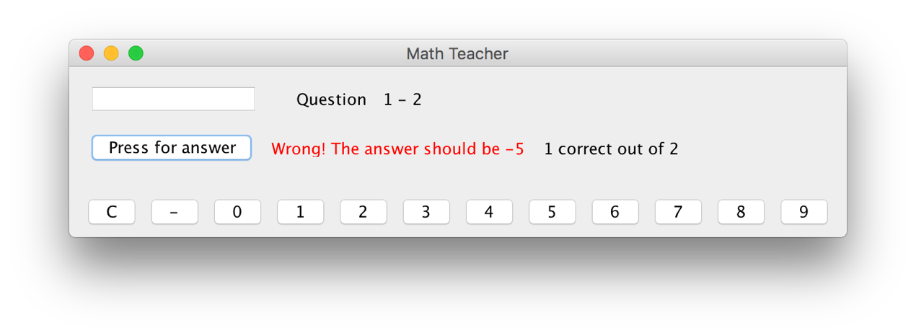
6. Press the “close” button in the top left corner to exit.